Upgraded Fish Egg Counter Project Proposal

1/21/2022

Version 1

Sydney McBee

Agusin Lopez

Sean Gilbert

Trueman Singleton

**Table of Contents**

**Overview / Executive Summary** **2**

**Background** **2**

**Product Design Specification** **2**

Concept of operations / User stories 2

Stakeholders 3

Requirements 3

Specifications 3

Deliverables 4

Initial product design 4

Initial product design diagrams 5

Verification plans 13

Functional Test 13

Environmental Test 13

Goopy Eggs Test 13

**Project Management Plan** **13**

Timeline, with milestones 14

Budget and Resources 15

Intellectual Property Discussion 15

Team and development process 15

# 

# **Overview / Executive Summary**

The fish egg hatching industry is a large market that requires over 10 million fish eggs to be produced in Oregon annually by ‘spring pick’ when they are ready to incubate. These hatcheries need an efficient way to produce eggs for species replenishment and enhancment, including ways to remove them, sort them, and count them. Our mission as a capstone team is to create a fish egg counter for the hatcheries by spring pick that is accurate and easy to use.

Our upgraded fish egg counter will be for fish egg hatcheries that want a more accurate counting device for their eggs, as well as images of their counted eggs. The current design is in need of technological updates, including further waterproofing, a higher accuracy of egg count, a faster count time, and a simple digital user interface. The design needs to be durable for the fish hatchery working style. Currently the hatcheries want to purchase egg counters because theirs are not accurate or fast, and they would also benefit from the added bonus of images of the eggs. In order to function in the hatchery environment, the device needs to be durable, easy to use with gloves on, waterproof, accurate, and require little attention/maintenance. The egg counter will have a location to dump a bucket of eggs, the eggs will move onto a rotating disc that will count the number of eggs that were dumped, and it will take a picture of each egg to be stored on a thumb drive.

As a team our goal is to have not only the basic functionality of an accurate egg counter but also images captured and stored of each egg that goes through the counting process. This way the hatcheries will have data stored of their eggs for future reference. The base requirement we have set for ourselves is an accurate count of eggs, even if the camera does not work fully.

# **Background**

Fish Hatcheries raise fish eggs to stock lakes and ponds as well as for human consumption. An accurate count of eggs benefit both vendors and customers purchasing the eggs. Currently, many fish hatcheries use volumetric measurements of eggs in order to estimate their numbers. This process takes time and effort for the workers and is not 100% accurate reliably. Egg sorters have been used in many fish hatcheries to count eggs or to sort them into unfertilized/fertilized/dead eggs. The eggs will be loaded by the bucket into the egg counter. The eggs will be wet and small, a bit smaller than a pea. A tray that a user could dump into the egg counter could hold anywhere from 5,000-10,000 eggs. The disk itself would hold roughly 250 eggs at a time.

# **Product Design Specification**

## **Concept of operations / User stories**

Our task is to design a fish egg counter for fish hatcheries that is durable, waterproof, accurate, very easy to use, and virtually hands off. The project should be completed by ‘spring pick’, which is when the eggs are ready to be incubated to be tested at Bonneville hatchery. The sponsor will then deliver it to the clients, which are various fish hatcheries. The counter should have the option to count a specific user input number of fish eggs, or count all of the eggs loaded into it. The counter may also have the ability to capture an image of every egg that goes through it and store it to be viewed by the egg hatchery workers for inspection. The main goal is to have a very accurate count of the eggs loaded into the counter. The user will be able to turn on the counter, dump the eggs in, choose either the amount of eggs they want counted, or choose to count all of the eggs deposited, and they will be able to walk away while it is counting. The counter should be able to be plugged into a computer via USB so software can be updated/debugged if need be. The parts should be easy to access for replacement of damaged or dead components.

## **Stakeholders**

Our industry sponsor is Curt Edmonson who is helping design and spec the egg sorter. He works with Pacific Roe Technologies, and Jensortor to provide equipment to fish hatcheries. The project team consists of John Lipor (faculty advisor), Sydney McBee, Agusin Lopez, Sean Gilbert, and Trueman Singleton.

## **Requirements**

* Must display an accurate count of eggs
* Must be waterproof
* Must work with very minimal user input i.e power button, less than three options for starting the device
* Must rotate the eggs on a disk similar to a tilted record player
* Must use water to push the eggs off the tray into a separate bucket after counted
* The eggs must be counted with a sensor (camera or another sensor)
* Must have a display to show information such as egg count and options
* Must have a ‘batch’ feature for the counter. This is an option to count the number of eggs deposited, or count a ‘batch’ of eggs (a specified number of eggs input by the user)
* Should take a picture of each egg
* Should store egg pictures in groups by batches
* Should store each picture of each egg in a thumb drive
* Should have replaceable parts
* Should have the option to update the software via USB

## **Specifications**

* Must use spring release toggle switches for UI
* Must be able to fit in a 4ftx4ftx4ft footprint
* Must cost less than $1000
* Must count fake eggs accurately up to 95% with test beads
* Should count fake eggs accurately up to 100%
* Should have a light sensor for each row of eggs to count rotations of disk
* Should be battery powered with a 18V ryobi drill battery
* Should count 500,000 eggs an hour
* Should use an STM32 processor
* Should use a ESP32-CAM sensor
* Should use a Raspberry Pi
* May be Wall Powered (Not Ideal)

## **Deliverables**

* Project proposal
* Weekly Progress Reports
* Final report
* ECE Capstone Poster Session poster
* Bill of Materials
* Github Repository
  + Electrical CAD: Schematics and board layouts, including output files (Gerbers, PDFs, etc)
  + Mechanical CAD: enclosures, mechanisms, including output files (STLs, PDFs, etc)
  + Final code
* A working prototype
* User Manual or User Video
* A manufacturable design

## **Initial product design**

This project is a fish egg counter which will take images and increment the count when it sees live fish eggs. This count will be displayed on an LCD screen and images downloaded into a USB stick. This will also have a side batching option.

The project will be done by effectively augmenting a current design to provide new imaging and counting capabilities using low cost and common parts. For example, the power will be handled through household Ryobi drill batteries, where the imaging uses $10 ESP32 cameras.

Specifically, the prototype will be done using existing and given parts; namely a wheel with holes for eggs, ESP32 cameras, a microprocessor and a simple electric motor. From there, a laser tripwire will trip when it sees a hole in the wheel and cause the camera to take an image. Then the eggs will be determined to be live, dead, or not in the slot and increment the count.

The largest risks for this project will likely be getting the cameras to take an image on time, accurately sorting between live and dead eggs on time, and dealing with quirks of the microprocessors/cameras.

Solutions to these risks are:

A. using an interrupt to trigger the image, and using dual threading to make sure the camera is ready at the time

B. Sorting will be handed using simple binary thresholds given some color ranges

Unanswered questions for this project are the exact means of placing the camera, if the eggs should be directly imaged, or imaged as a greater whole. Both have advantages and disadvantages; having a camera photograph a larger space means less cameras can be used meaning less wiring and moving data. However, there is the possibility of picking up more debris and glare versus more direct imaging which requires more cameras. The other main question is the speed of the cameras, this is important to ensure that the microprocessors have the bandwidth to meet specifications.

In conclusion this project is fairly realistic and excluding any debugging, should be fairly reasonable to meet the deadline in late June. It would not be unreasonable to suggest that a working prototype could be made by mid-April, and further refinement will be determined.

If there are unexpected issues or a much larger time constraint than expected, the use of having photoresistors to counteggs is an option. This has a tradeoff of also counting dead eggs and potential debris which is undesirable. There is the added benefit that the eggs are sorted beforehand so the number of dead eggs should be somewhat low.

## **Initial product design diagrams**

**Diagram Summaries**

* Figure 1: Simplest Fish Egg L0 is a broad overview of the software. The goal is to illustrate the initialization of the machine and the output
* Figure 2: Shows all the main connections between hardware parts
* Figure 3: Illustrates the various physical parts and software combined, and somewhat shows various user inputs (LCD, buttons, etc)
* Figure 4: A data flow diagram to explain how the machine is started and when it will decide to stop. It is kept semi-independent from imaging
* Figure 5: This is a diagram to illustrate the image taking process before processing. This covers the important step of when and how to take the image before being sent to processing.
* Figure 6: Diagram shows Input images coming in from Figure 5, and how it will determine the quality of the egg, and how the eggs will be both counted, and saved on a local memory
* Figure 8: Shows an existing Egg Counter. This is important because it illustrates the existing hardware and existing structure to base on
* Figure 9: A Hand Drawn Diagram that will be an imitation of the existing hardware which will be used for prototyping. This maintains the disc and motor, and reinterprets the interrupt switch, hoppers, and egg retrieval for simulating the existing model

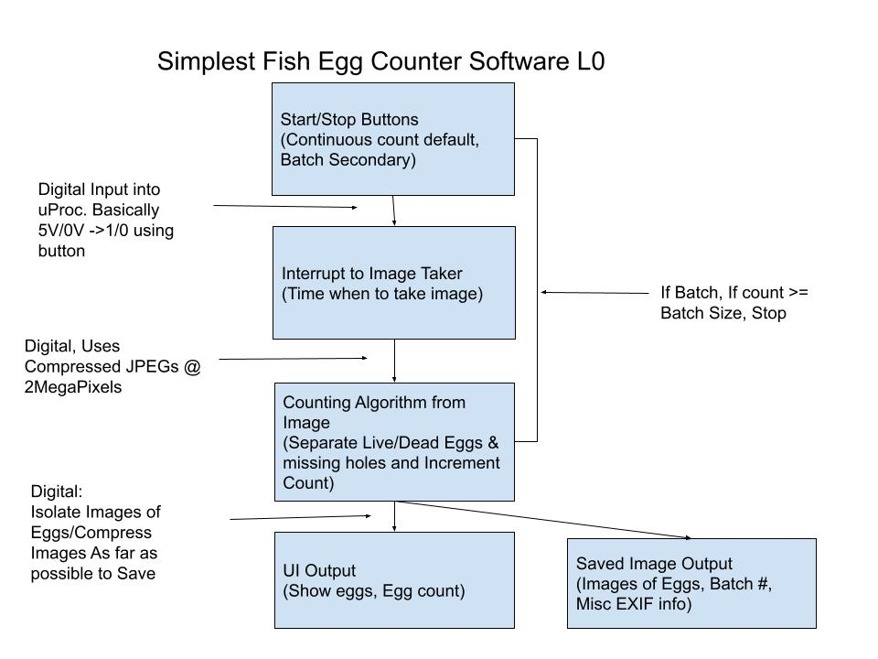

Figure 1: Software L0 Dataflow

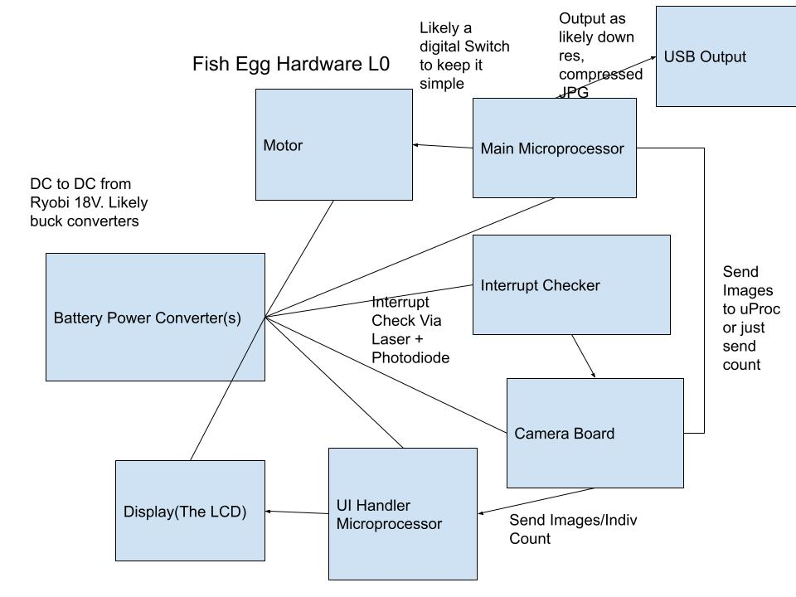

Figure 2: Hardware L0 (Kept separate as the hardware is much more messy with the battery)

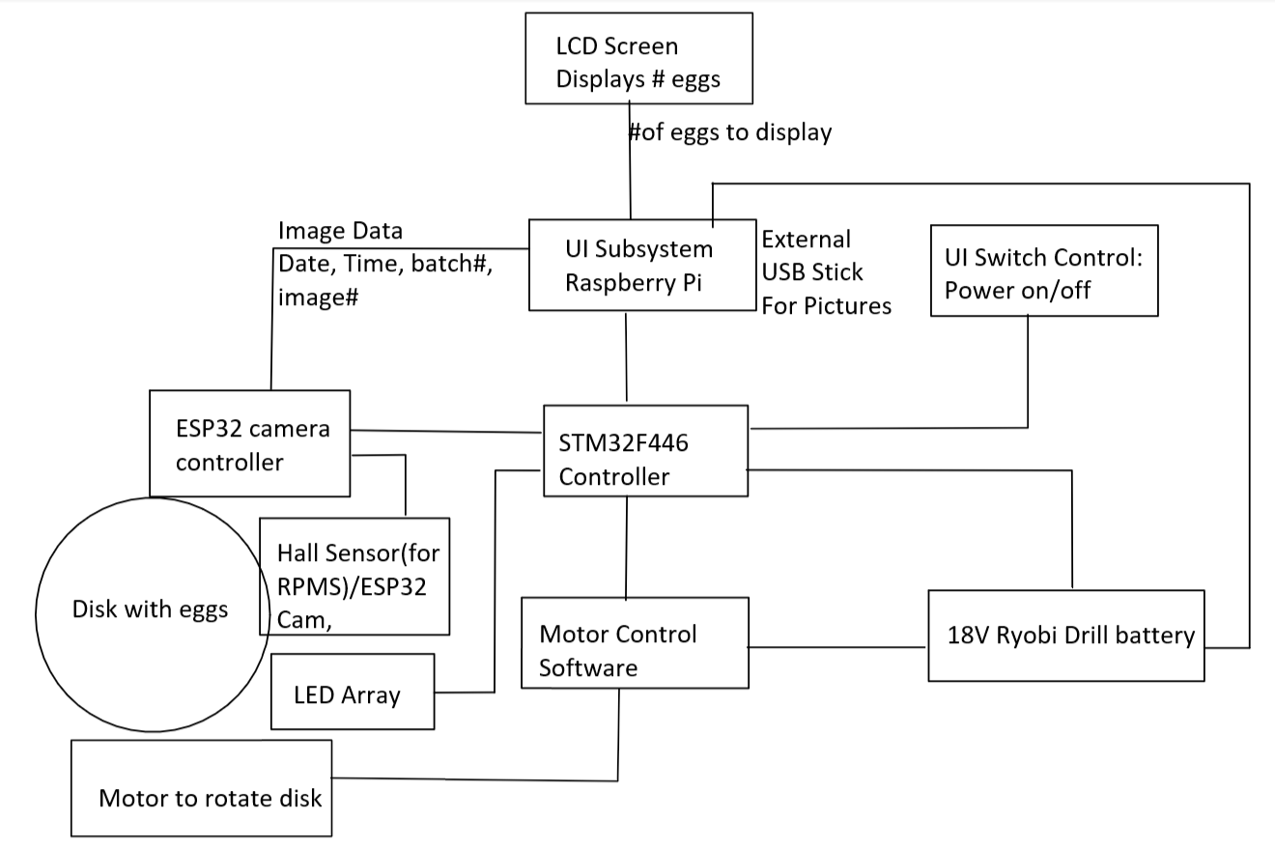

Figure 3: L1, Overarching Description using more specifics

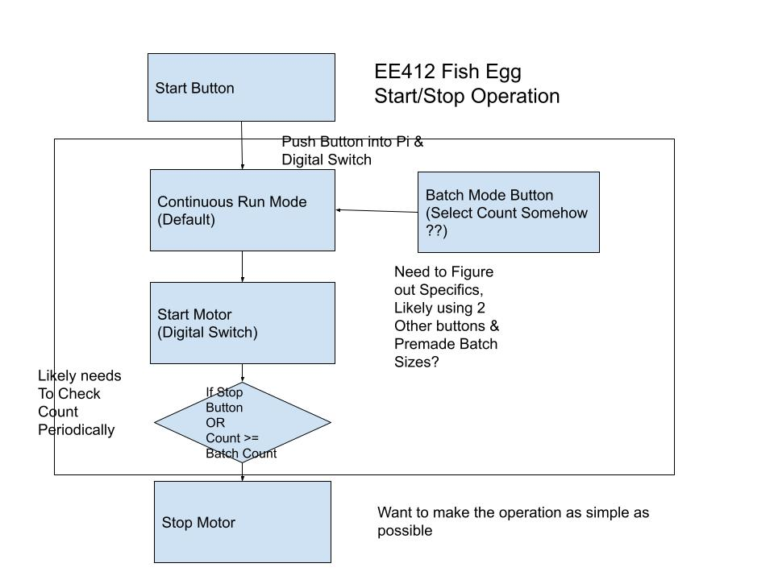

Figure 4: Start/Stop Operation Software Flow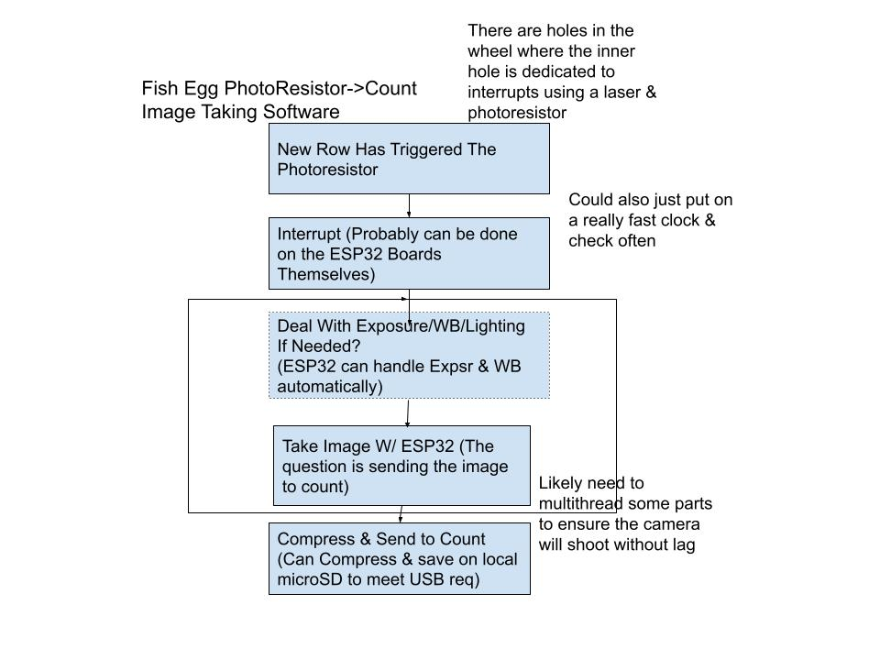

Figure 5: Interrupt & Image Taker Flow

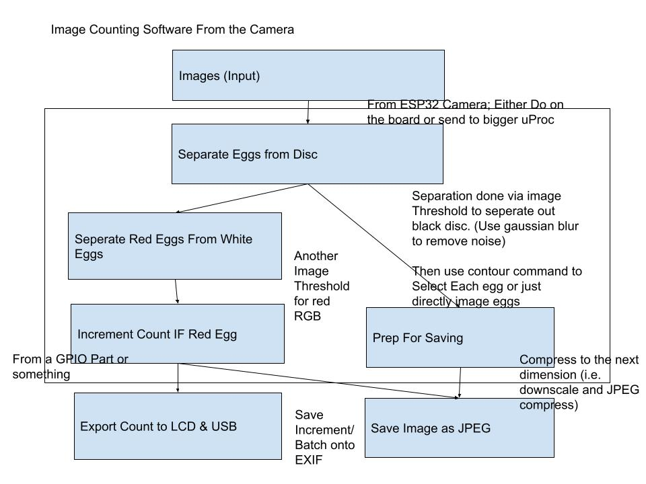

Figure 6: Main Image Counting & Saving Software, sorting red, white and no egg

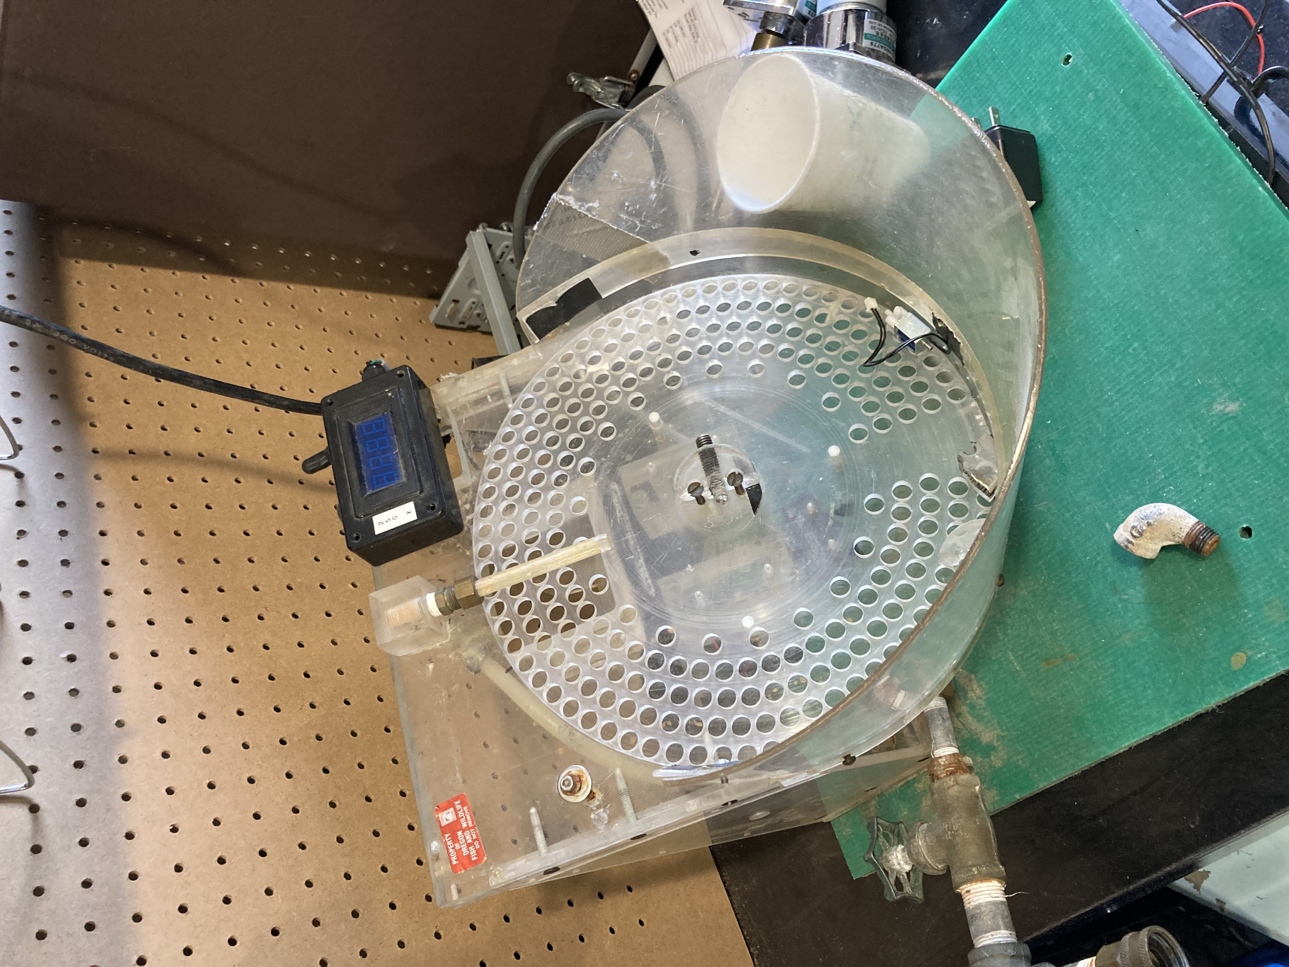

Figure 8: Example of Older Egg Counter (Counting via wheel revolutions)

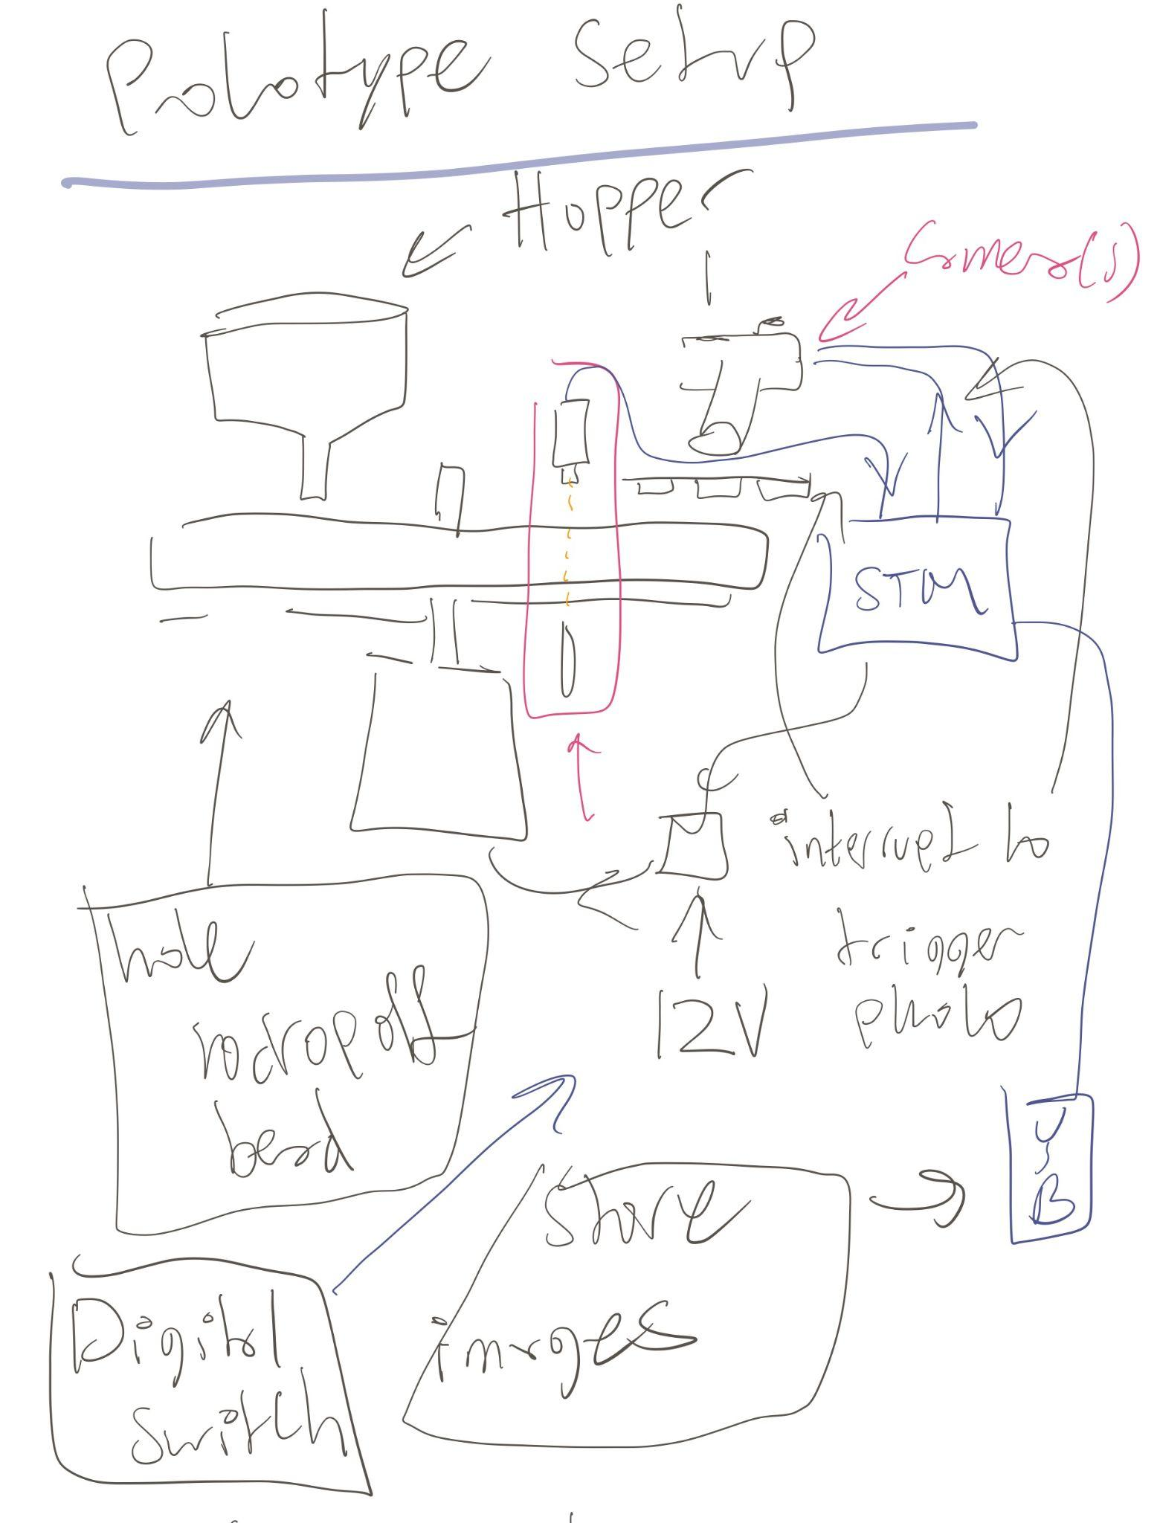

Figure 9: Early Prototyping Setup Idea

## **Verification plans**

### Functional Test

Initial testing will consist of a batch of imitation eggs placed in the housing unit of the counter. We will be looking for accuracy of the counting of eggs and overall functionality of the motor. This will ensure that testing moving forward on other components of the project will have a working foundation.

The final product will be tested on the following critical pass/fail criteria:

* Power On with flip of switch (Power On design subject to change)
* Disk holds ~250 fish eggs
* Disk rotates at 25 RPM
* User Interface displays egg count and batch number
* User Interface allows for batch input
* Counts eggs to an accuracy of 95%
* Ejects counted eggs to separate tray utilizing water system (water system yet to be designed)

The final product will also be tested for the following non critical pass/fail criteria:

* Take an image of each egg in the row every two seconds
* Store an image of each egg on a thumb drive
* Software updates via thumb drive

The final egg counter will be tested at Bonneville Dam with the employees of the hatchery utilizing real fish eggs and follow the same criteria.

### Environmental Test

In order to have a safe and functional product for the hatcheries we have to ensure that it is waterproof. In order to test our product we will utilize real eggs and run our egg ejecting water system.

### Goopy Eggs Test

When the eggs arrive at the counting process they have gone through a hardening process to prevent damage. They are also coated by a mucus-like substance, this substance can cause slick conditions for the holes on our rotating discs. We will be conducting tests with real fish eggs towards the end of the testing process to ensure that fish egg particulates will not interfere with the counting process and accuracy.

# **Project Management Plan**

## **Timeline, with milestones**

By the end of march our team will decide if we are going to use the cameras to count the eggs and/or image them, and if not we will switch to plan B which is to utilize sensors to count the eggs instead of digital processing.

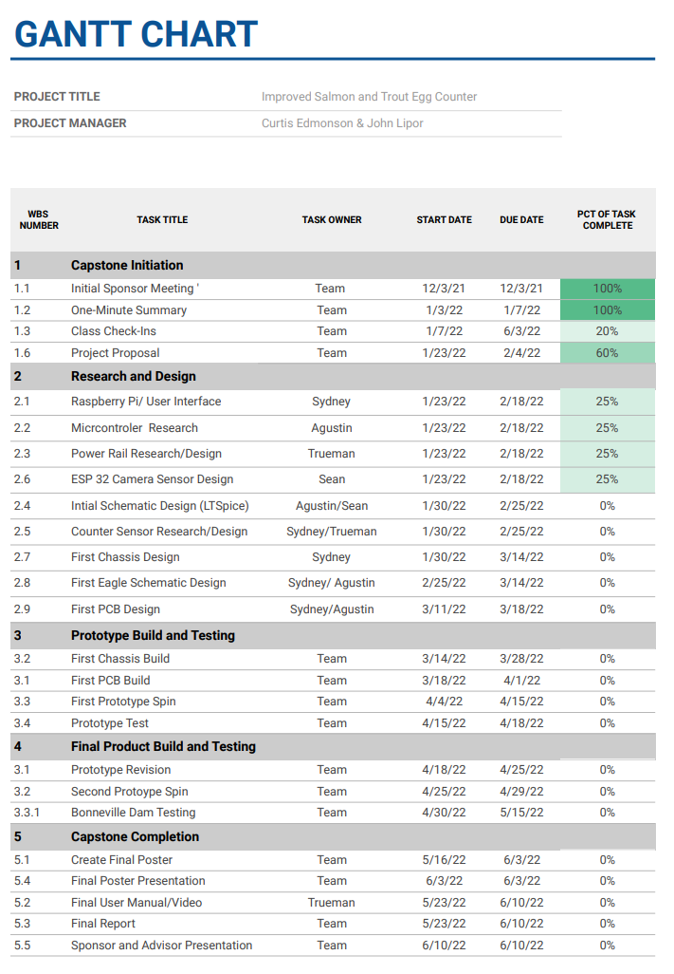

Figure 10: Gantt Chart - Titles and Dates

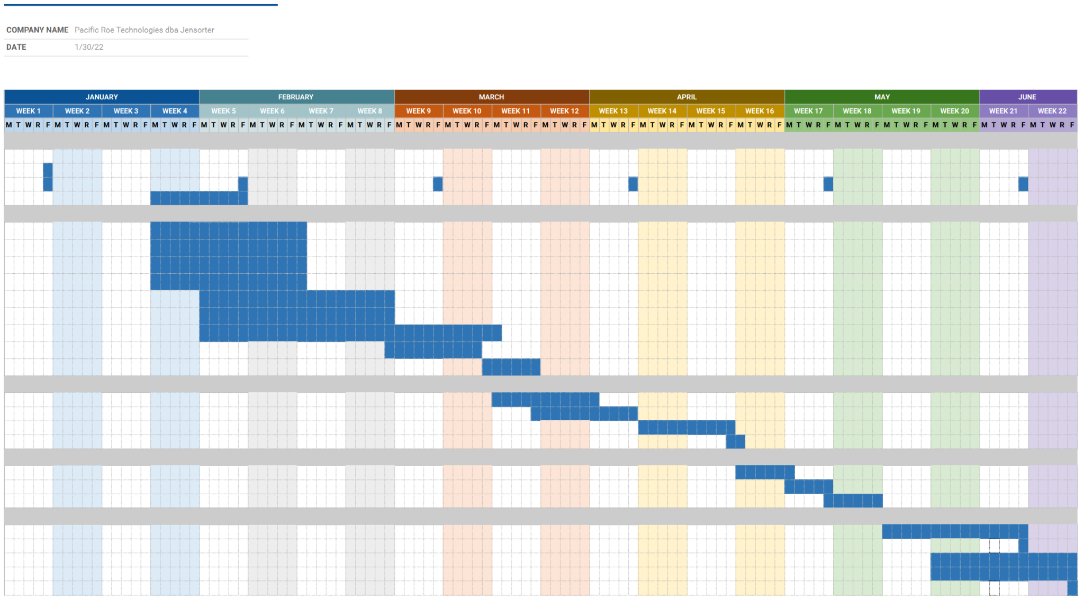

Figure 11: Gantt Chart - Weekly Columns

## **Budget and Resources**

Total hardwear must be less than $1000, and around $500 is the goal. Our industry sponsor will provide us with the contact information from previous capstone teams and their documentation.

Pacific Roe Industries is providing us with a shop including a CNC router and prototyping materials. They are providing us with the STM boards, ESP32 Cameras, Raspberry Pi’s, and LCD screens. They are providing us with black ABS (a hard plastic) as well as clear acrylic for the disk. They are providing us with ryobi batteries as well as the motor for the disk. They will also provide us with an aluminum frame for the final product. We will be mostly working in the senior capstone lab and in the workshop provided in Hillsboro. We have a locker at PSU to store components in. PCB express will be printing our circuit boards.

## **Intellectual Property Discussion**

The code we are using and updating is open source, and we have a license for our Github repository, but as far as IP for the roe sorter design that is owned by Pacific Roe Industries.

## **Team and development process**

We will be working on specific parts of the project individually, and each team member will have overriding power over their respective task. This means if there is a disagreement over someone's specialty, they will have the final word and will be able to proceed as they see fit. Currently, this is the task division and each members respective skills:

Sydney: UI, 3D model armature, communication vector with industry sponsor and faculty advisor, photodiode (skills include Fusion 360, PCB layout, 3D printing, microcontrollers)

Agustin: STM32 Microcontroller, motor (CAD circuit design and layout, hardware and hardware debug)

Sean: Hooking up Camera & Image Processing (photography/image processing, can 3d model, python, hardware)

Trueman: Battery, user manual, memory allocation, photodiode